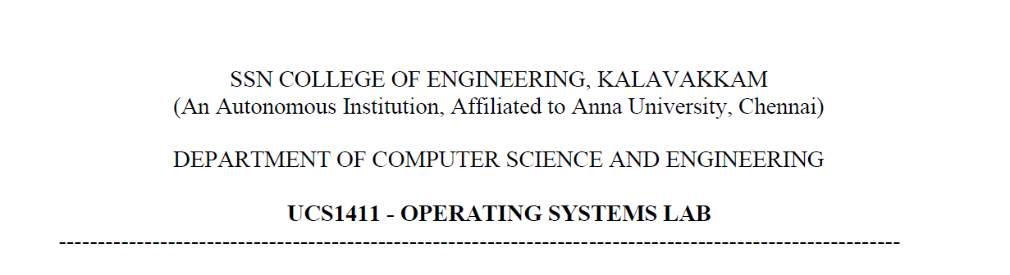

**NETWORKS LAB**

**EXERCISE 2**

Name: Jayannthan P T

Dept: CSE ‘A’

Roll No.: 205001049

**Aim:**

Develop a socket program to establish a client server communication. The client sends data to server. The server in turn sends the message back to the client. Send multiple lines of text.

**Algorithm:**

**SERVER**

1. Create a socket using socket() system call.

2. Bind() is used to bind the socket with a specified address defined by sockaddr_in pointer, with the address, family, port set accordingly, bzero() is used to clear the address pointer initially.

3. listen() to make the created socket listen for incoming connections, maximum no of connections that can be accepted is specified here.

4. accept() call to make the server accept any connection requests, the parameter sockaddr_in accept() holds the requesting clients address, with which the messages are addressed to.

5. Read() is used to read data from client into a temporary buffer.

6. Sends the same message back to the client using write() system call.

7. Then the received message is displayed.

**CLIENT**

1. Create a socket using socket() system call.

2. The socket descriptor is noted using which a connect() call is made to connect to server, whose address is to be specified as a pointer of sockaddr_in in the sockaddr field of connect().

3. The sockaddr_in pointer holds the address, set by user, some port, ip of the server machine, respectively.

4. Once the server accepts the call, the client requests input from the user, sends it to server with the write() call. The server returns the same message and it is read using read() system call.

**Code:**

**Server**

#include <netinet/in.h>

#include <stdio.h>

#include <stdlib.h>

#include <sys/socket.h>

#include <string.h>

#include <sys/types.h>

**int** main(**int** argc, **char** **const**\* argv**[]**)

{

**int** port=atoi(argv[1]);

**int** serSockID = socket(AF_INET, SOCK_STREAM, 0);

**char** serMsg[255] = "Hello Client";

**struct** sockaddr_in servAddr;

    servAddr.sin_family = AF_INET;

    servAddr.sin_port = htons(port);

    servAddr.sin_addr.s_addr = INADDR_ANY;

    bind(serSockID, (**struct** sockaddr*)&servAddr,sizeof(servAddr));

    listen(serSockID, 1);

**int** clientSocket = accept(serSockID, NULL, NULL);

    printf("\nConnected\n");

**int** connected=1;

    while(connected)

    {

        read(clientSocket,serMsg,sizeof(serMsg));

        printf("Message recieved: %s\n!!!Sending message again to client!!!\n\n",serMsg);

        send(clientSocket, serMsg, sizeof(serMsg), 0);

        if(strcmp(serMsg,"exit")==0)

        {

            connected =0;

        }

    }

    return 0;

}

**Client**

#include <netinet/in.h>

#include <stdio.h>

#include <stdlib.h>

#include <sys/socket.h>

#include <sys/types.h>

**int** main(**int** argc, **char** **const**\* argv**[]**)

{

**int** port=atoi(argv[1]);

**int** sockD = socket(AF_INET, SOCK_STREAM, 0);

**struct** sockaddr_in servAddr;

    servAddr.sin_family = AF_INET;

    servAddr.sin_port= htons(port);

    servAddr.sin_addr.s_addr = INADDR_ANY;

**int** connectStatus= connect(sockD, (**struct** sockaddr*)&servAddr,sizeof(servAddr));

*//printf("\nConnected\n");*

    if (connectStatus == -1) {

        printf("Error...\n");

    }

    else

    {

**int** connected=1;

**char** strData[255];

        while(connected)

        {

            printf("\nEnter data to send to server:");

            scanf(" %[^\n]s",strData);

            write(sockD,strData,sizeof(strData));

            recv(sockD, strData, sizeof(strData), 0);

            printf("Message: %s\n", strData);

            if(strcmp(strData,"exit")==0)

            {

                connected =0;

            }

        }

    }

    return 0;

}

**Output:**

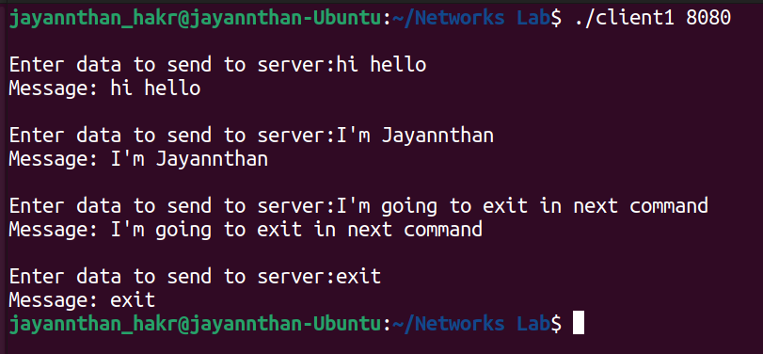

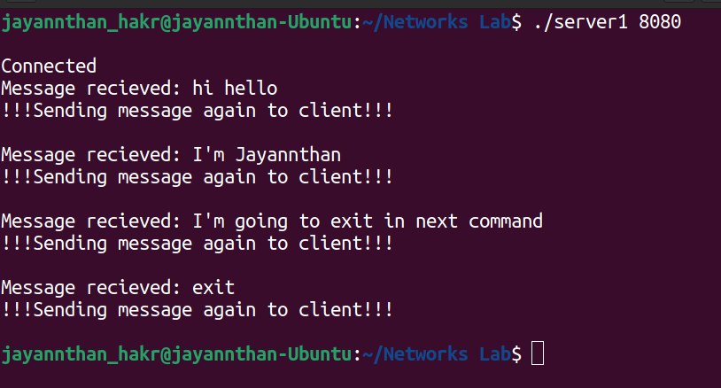

**Learning outcome:**

Learnt to create connection using sockets

Learnt to communicate between server and client using socket